Invasion point vol.1

(1~11 ) (11~17) (24~36) (1~23)
(B’s 10 is a good point) (If B plays A insted 17, (W’s 32 is good (B 16 is inportant)
later B is a good point). Move)
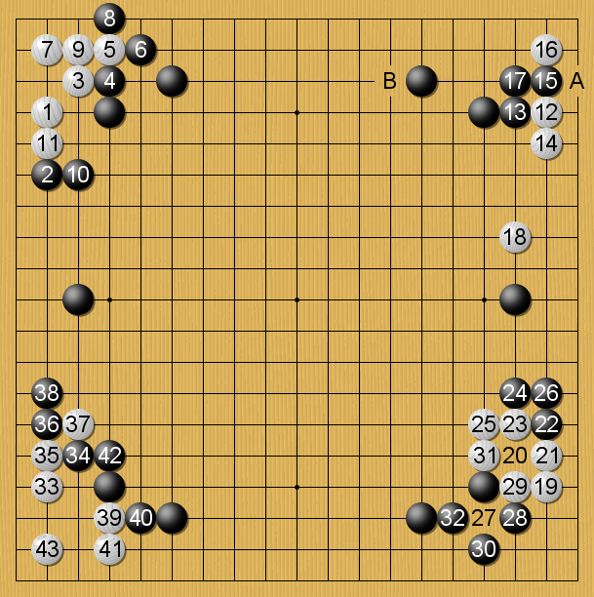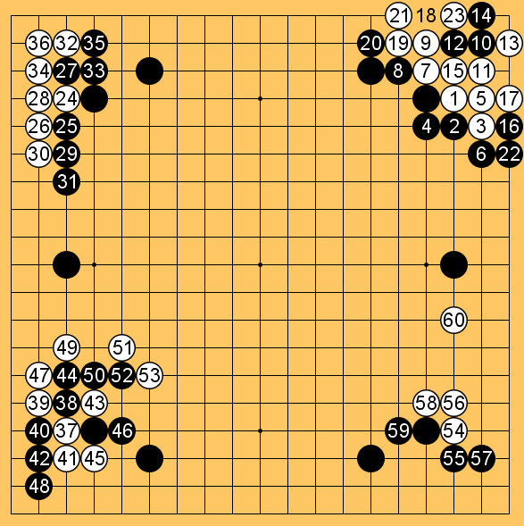
(18~27) (29~42) (37~53) (54~60)
(B’s 42 is a good point) (If W wants attack) Normal one
(If B wants profit)
(1~9) (10~16)
Good for White
(But If B really want to influnce, possible)
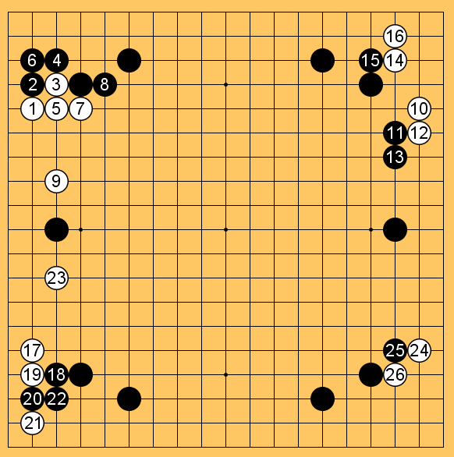
(17~23) (24~26)
These diagrams are Become to same one.

By in seong

