After pattern technic vol.1
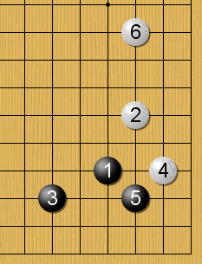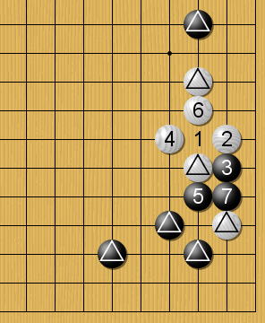
Pattern Black 1 is good move
(Black has good territory)
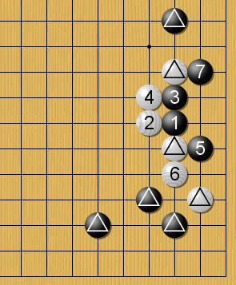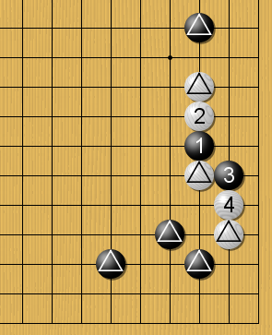
Good for Black White 2 is best answer
(White stones getting weak) (Black3 is a bad move)
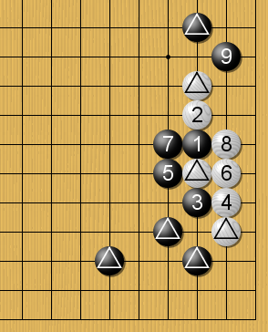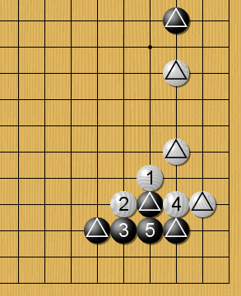
Good for Black White 1 is a urgent move
(B 3 is a right move) (If B play else where, W get good position)
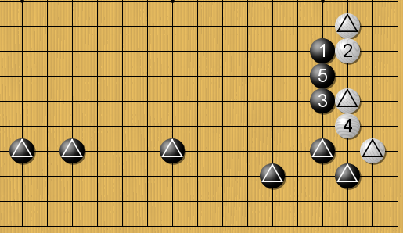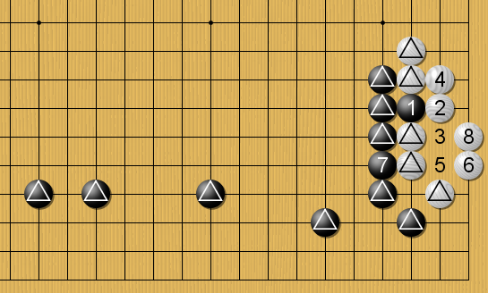
Black gets influence continue Black’s 3,5 are good move

