3-4 point enclose vol.2
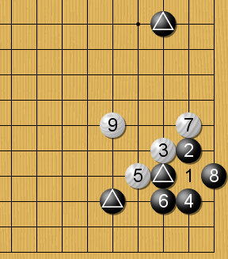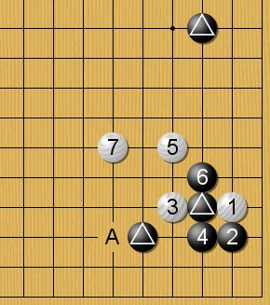
Good for White Balanced
(W’s sacrifice strategy) (W’s good reduction continuous A is a good point)
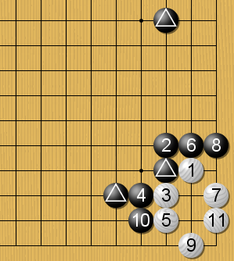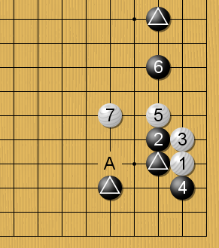
Good for black Balanced
(White can live but too small) (White 3 is a proper move and
White’s A is a good move)
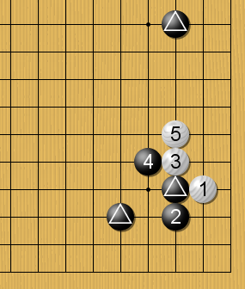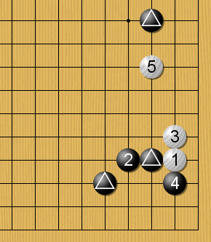
Good for White Balanced
(White easy to settle)

